Chapter 10, Solution 13.

Nodal analysis is the best approach to use on this problem. We can make our work easier by doing a source transformation on the right hand side of the circuit.

18 Ω
3 Ω
+
V_{x}
−
j6 Ω
–j2 Ω
40∠30º V

+
−
50∠0º V

+
−

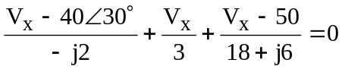

which leads to V_{x} = 29.36∠62.88˚ A.

